**DOCUMENTATION OF THE SETUP PROCESS.**

**Introduction:**

This document outlines the steps I took to set up my developer environment for software engineering projects. It includes the installation of necessary tools, configurations, and customizations made during the process.

1. Installing windows 11.

**Steps**

1. Visit the Windows 11 Download Page:

Open your web browser and navigate to the [Windows 11 download page](https://www.microsoft.com/software-download/windows11).

1. Download the Installation Media:

On the download page, click on the "Download now" button to download the Windows 11 Installation Assistant.

1. Run the Installation Assistant:

Locate the downloaded file in your downloads folder and run it.

1. Follow the Installation Instructions:

The Installation Assistant will guide you through the process. It will check your system for compatibility and prompt you to back up your files.

After verifying the compatibility, click on "Accept and install" to start the installation.

1. Complete the Installation:

The installation process will take some time. Your computer will restart several times. Follow any on-screen prompts to complete the installation.

Once the installation is complete, you will be greeted with the Windows 11 welcome screen.

Verification

To verify that Windows 11 is installed, you can check the system information:

1. Press Win + I to open the Settings app.
2. Go to System > About.
3. Check the "Windows specifications" section to confirm that you are running Windows 11

**2. Installing Visual Studio Code:**

* Downloaded Visual Studio Code from <https://code.visualstudio.com/Download>.
* Followed the installation instructions and installed it successfully.

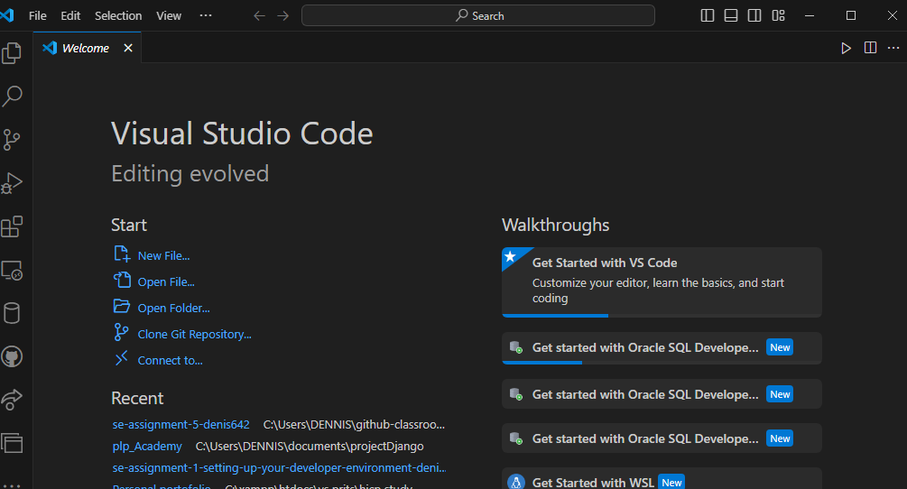

I also installed several extensions as shown below in the following screenshot by clicking on my keyboard (Ctrl+shift+x) then search for the required extension and then install.

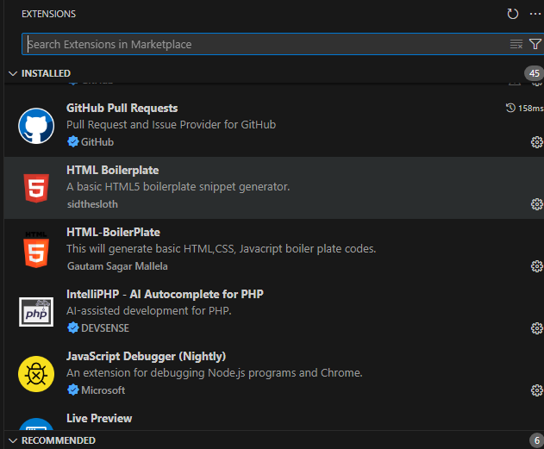

**3. Setting up Git and GitHub:**

Installed Git from [here](https://git-scm.com/downloads) and GitHub from [https://github.com](https://github.com/)

Configured Git with my username and email using the following commands from my gitbash.

git config --global user.name

git config --global user.email

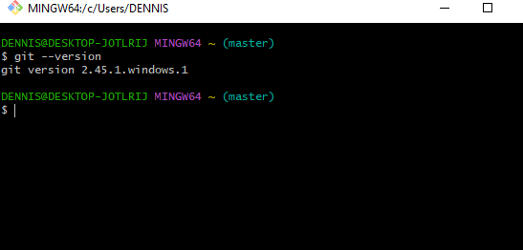

1. **Python installation.**

I installed python from the official website [http://wwww.python.org](http://wwww.python.org/)

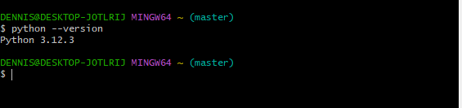

1. **MySQL installation.**

I downloaded the MySQL from <https://dev.mysql.com/downloads/windows/installer/5.7.html>

Followed the step by step process and installed it.

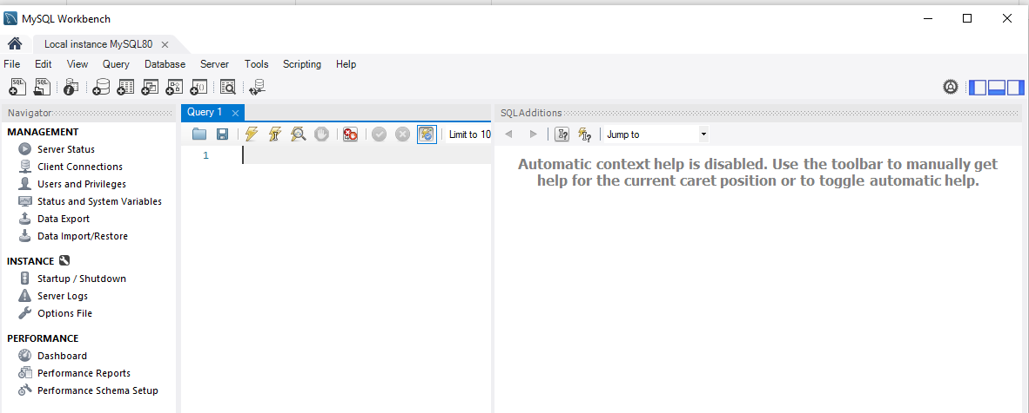

Above is a screenshot of my MySQL workbench.

CHALLENGES FACED DURING SETUP AND STRATEGIES EMPLOYED TO OVERCOME THEM.

1. Initially, I had to ensure my system met the minimum requirements for Windows 11. Additionally, I experienced a delay due to a large update that needed to be downloaded. To overcome these issues, I consulted the official Windows 11 installation guide and followed troubleshooting tips provided on the Microsoft support website.

2. Another challenge was on configuring Git on Windows to solve this i followed the documentation provided in the official website of the git and successfully did it.

3. Networking and connectivity issues where i solved this by looking for a strong internet connection to ensure faster downloading of this some of this tools which some were too large